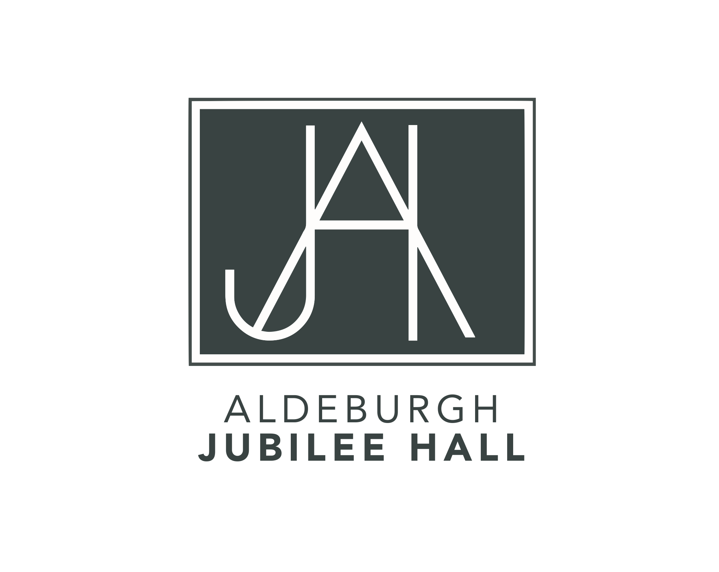

CALL FOR TRUSTEES
ALDEBURGH JUBILEE HALL

Organisation
Aldeburgh Jubilee Hall is a much-loved community arts venue on the Suffolk coast, making music, theatre and the wider arts central to Aldeburgh and the surrounding area. The Hall has been an important part of Aldeburgh’s social fabric since 1887 when it was built to celebrate Queen Victoria’s Golden Jubilee.

A salaried Hall Manager, together with a number of part-time staff and volunteers, hold responsibility for the day-to-day running of the building.

Programme
The Aldeburgh Jubilee Hall is committed to providing high-quality entertainment for all members of the town and surrounding communities from the youngest to the oldest. It reflects this in the diversity of its programme, presenting an ambitious range of events from theatre, classical concerts, jazz, tribute bands and talks, to youth and community arts programmes, drawing festivals and comedy nights. In addition, the Hall hosts a number of annual festivals and events which bring visitors to the town, such as the Literary Festival, the Poetry Festival, a summer theatre season from Aldeburgh Classical Theatre, and concerts as part of the Aldeburgh Festival and Aldeburgh Young Musicians. The Jubilee Hall takes pride in showcasing local talent through its partnerships with schools and community organisations.

Role
Aldeburgh Jubilee Hall is a Charitable Incorporated Organisation (CIO). We are at an exciting phase in our development having recently received a substantial Arts Council England Cultural Recovery Fund grant and are reopening after lockdown.

We are seeking Trustees to join our Board of Trustees who will help us build on our local reputation, champion our work, be ‘hands on’, and who can appreciate the importance of the legacy of this historic venue.

If you have a passion for bringing professional, high-quality entertainment to Aldeburgh and for supporting and nurturing community arts, for taking an active role in the growth of an important heritage venue and the time and skills to help us take the Hall to the next level, we would love to hear from you.

We are keen to consider a wide variety of individuals, but are particularly interested in appointing Trustees who live locally. We welcome younger Trustees and those with expertise in the following areas:

- Fundraising
- Programming and Events
- Venue operations, volunteers and staffing
- Finance and Legal

Knowledge and Skills

- The work, history and aspirations of Aldeburgh Jubilee Hall
- Strategic insight for short- and long-term planning
- Interpersonal skills
- Providing support to the salaried staff

Commitment
Six Trustee meetings per year and, depending on expertise, membership of one of the specialist committees. Trustees will also be expected to provide advice between meetings, and to spend some time supporting staff where their expertise will be helpful. Trustees are encouraged to attend as many events as possible and to help build an active and enthusiastic community of staff and volunteers working together for the Hall, its performers and audiences.

Trustees are expected to champion the work of Aldeburgh Jubilee Hall, to act as ambassadors at events and performances, and to represent the organisation where appropriate.

How to apply
For an informal chat about the role please contact one of the current Trustees or email ajhtrustees@gmail.com and Ann Barkway, Heather Newill or David Mackie will be in touch in the first instance.

Expressions of interest, including a brief CV, should be sent to ajhtrustees@gmail.com.

Aldeburgh Jubilee Hall aspires to be an equal opportunities organisation, and welcomes applications from all suitably qualified persons regardless of their ethnicity, sex, disability, religion/belief, sexual orientation or age.

